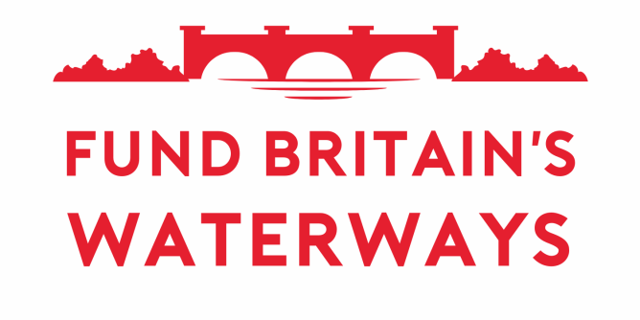
Template Letter for FBW members, champions and supporters to invite MPs to view the Westminster campaign cruise 2025
Complete highlighted sections and remove highlighting before sending

Dear [insert name of MP]
Fund Britain’s Waterways Westminster Campaign Cruise, Wednesday 7th May 2025
- On Wednesday 7th May a flotilla of boats will arrive at the Palace of Westminster as part of the Fund Britain’s Waterways (FBW) campaign, calling for sustainable funding for our inland waterways.
- Boats will travel in convoy up the River Thames, arriving from 10:30 a.m., with the main gathering off the Palace of Westminster at 11:00 a.m.
- I would like to invite you to view the boats from the terrace.
2025 opened with sustained heavy rainfall in the North West causing the collapse of embankments on both the Bridgewater Canal and the Huddersfield Narrow Canal on New Year’s Day. Both canals will need complex, lengthy and expensive repairs and are now closed for the foreseeable future, with substantial impact on boaters, businesses and local communities.
These are not isolated incidents. Extreme weather events are increasing in frequency and severity because of climate change. The Environment Agency estimated in its 2021 report on the Impact of Climate Change on Asset Deterioration that maintenance budgets may need to increase by 30-80% in order to future-proof the waterway network.
This is why the Fund Britain’s Waterways (FBW) campaign has submitted evidence to the Government's 2025 Spending Review. We cited recent embankment collapses as proof that more investment is needed to protect canals and rivers from severe weather events. Our submission calls for a review of waterway funding to safeguard the benefits of Britain’s inland waterways for future generations. With the Spending Review outcome expected in June, now is the time to raise awareness among the public and policymakers.
The FBW campaign cruise for 2025 will start in late March with the departure of a group of narrowboats from Doncaster, which will be joined by others from points across the country. Boats will call in at events organised at marinas or cruising clubs to which local politicians including MPs have been invited to build awareness along the way of both the value and the risks to our precious and threatened waterways.
I would appreciate your presence on the terrace of the Palace of Westminster at 11:00 a.m. on 7th May to show your support for our waterways.
Yours sincerely,
[signature, full name, address and postcode, email address, phone number]

